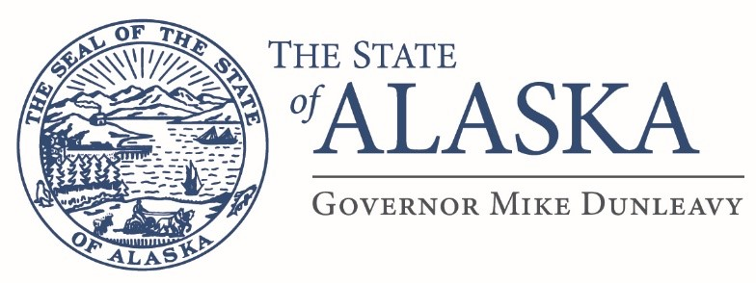

Department of Revenue

TREASURY DIVISION
CASH MANAGEMENT
PO Box 110406
Juneau, Alaska 99811-0406
Main: 907.465.2360
Fax: 907.465.4397

DEPOSITORY SUBACCOUNT REQUEST
Title: (DMV Only) FEIN:
City/Town Location:
(For Treasury use only)
Subaccount #: Date Added to Subaccount List:
Department: | Physical Address:
Division:
Mailing Address:
City: AK Zip Code: | City: AK Zip Code:
- Provide a brief description of the types of payments (cash or checks) that will be deposited to this subaccount and provide an estimated dollar amount being deposited each week (Attach extra sheets if necessary).

- Will there be cash and coin deposited? Yes No

- Select the bank to which deposits will be delivered. If choosing Wells Fargo or First National, please provide a brief justification.
Key Bank (Primary) Wells Fargo First National Bank Alaska BEACHES/ACH Transfer

- Will this account use Remote Deposit Capture (RDC)? Please see AAM 50.140 Yes No
If yes, please provide the list of names that need access to RDC (Attach extra sheets if necessary):

Name | Email Address | Phone Number

- If you would like to request direct coding for this subaccount please download and complete a Direct Coding Template Spreadsheet from the ‘Forms’ section of the Cash Management website and submit it with this application. http://treasury.dor.alaska.gov/Cash-Management/Forms

- Please provide the contact information for the person who is responsible to receive and process NSF items, foreign currency adjustments, and other bank adjustments related to this subaccount.

NSF Contact Name: Phone:
Email:

Subaccount Requestor: Phone: ___________________________________

All Deposits to this sub account will comply with cash control procedures as stated in the Alaska Administrative Manual, section AAM 50 – Cash

Approved by Dept Finance Officer: Date: ___________________________

